Name: xxxxxx xxxxx xxxxxx xxxx Session: Fall 2016
Student Project: Catholic Schools in United States of America Course: Time Series

Catholic Schools in United States of America
Introduction

The predominant religion in the Philippines is Roman Catholic, hence, most of the private schools in the country are managed and run by religious congregations. I completed my secondary education from a Catholic school and even obtained my college degree from a Catholic University which is not surprising. However, as I searched the web for data I can use for Time Series project, I was surprised to know that there are a number of Catholic schools in the United States. This piqued my interest, therefore, the objective of my time series project is determine the model of the number of Catholic schools in the United States of America.

Data

The number of Catholic schools from 1975 to 2010 can be found from two sources:

- 120 Years of American Education: A Statistical Portrait - http://nces.ed.gov/pubs93/93442.pdf

- Digest of Education Statistics 2011 - http://nces.ed.gov/pubs2012/2012001.pdf

Both papers provided the number of Catholic schools in elementary and secondary education. Hence, I decided to model the total number of Catholic schools.

The chart below shows the number of Catholic schools in US from 1975 to 2010.

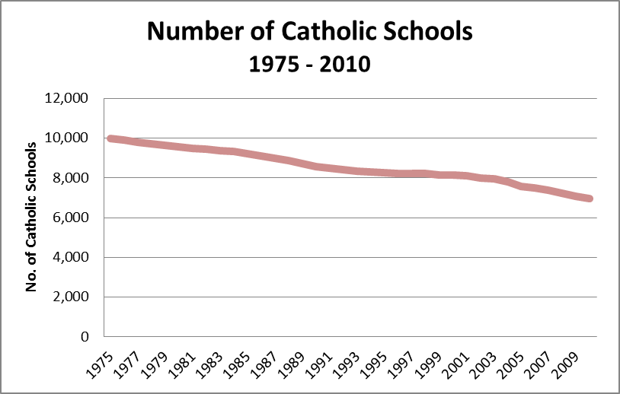

A downward trend is very evident which suggests the series is not stationary.

Analysis and Model

Next, I computed the autocorrelation function of the series to check the relationship of the past and current number of Catholic schools in US based on the formula in page 109 of the reference book.

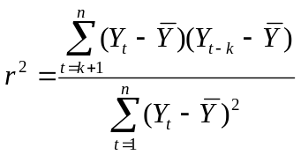 for k=1,2,3,…
The chart below further confirms that the series is not stationary as the chart shows that the autocorrelation at lag 1 is near 1 and decreases further beyond zero at lag 15. It starts to ascend at lag 28 until it is almost zero at lag 35.

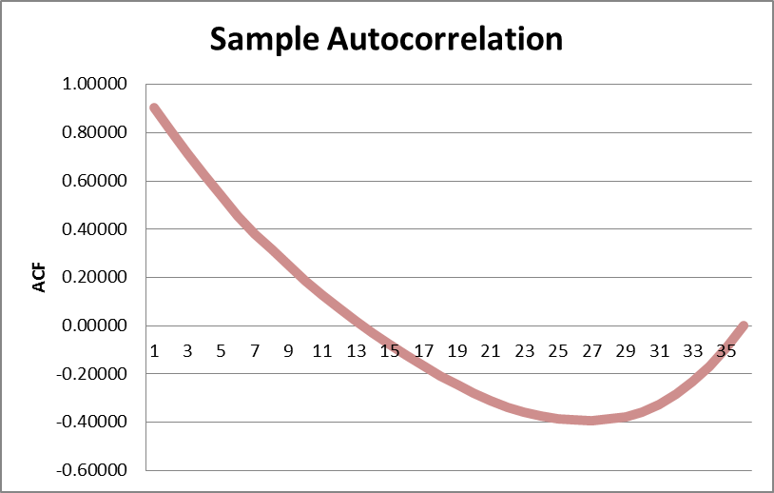

To make the series stationary, I used the differencing technique. Charts below show the results of the first and second differenced together with their ACF.

First Difference

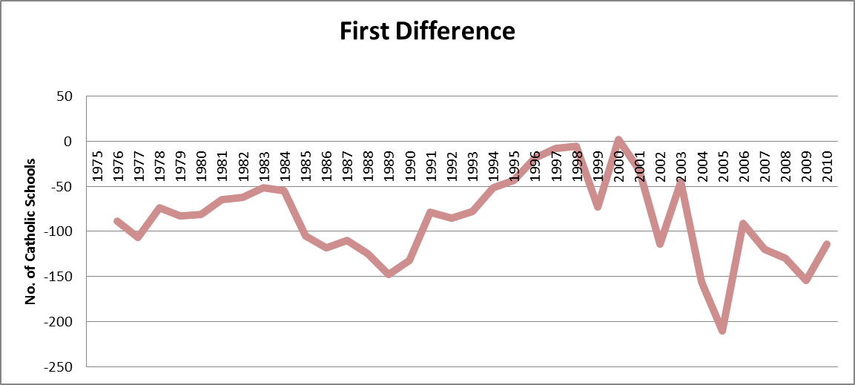

In contrast to the original series, the figures fluctuate which could suggest staionarity of the first difference series. This could be checked through its ACF below that converges to zero at long lags which also denotes that the series could be an autoregressive series.

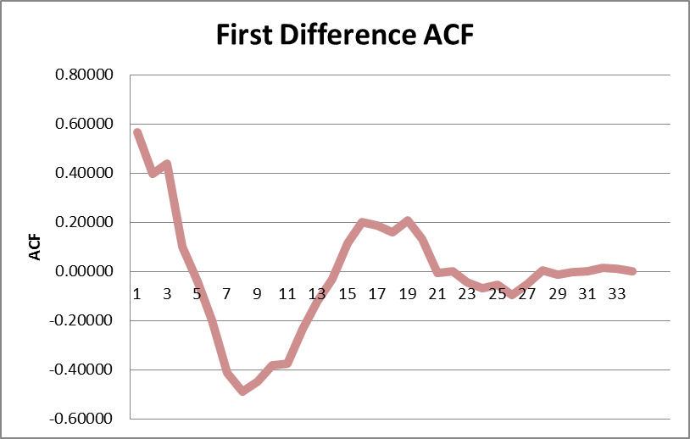

Second Difference

Since the first difference is stationary, it follows that the second difference is also stationary as confirmed by the charts below.

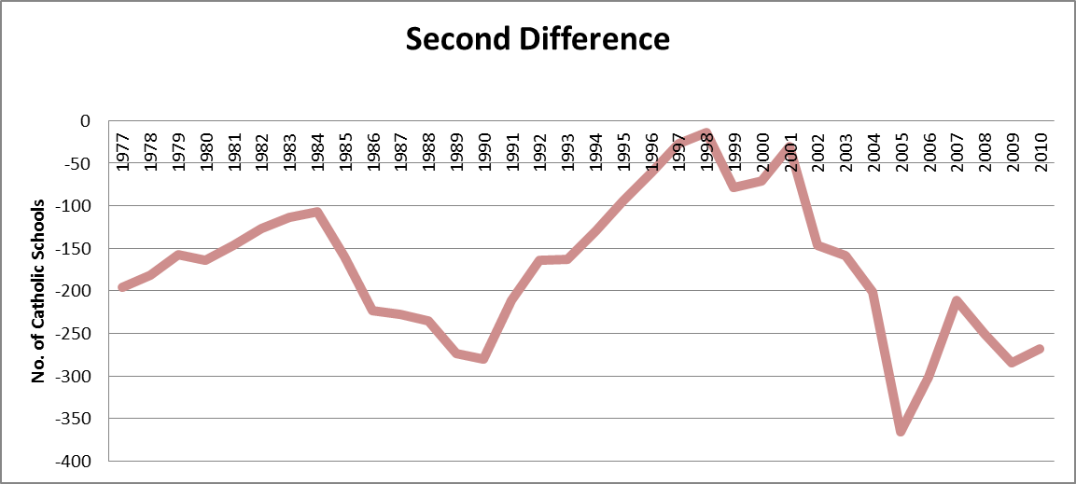

The second difference series follows the pattern of the first difference. Even its ACF somehow replicates the ACF of the first series.

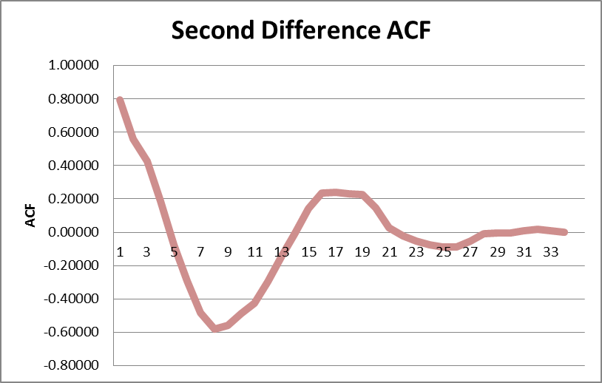

It is possible to fit the series to autoregressive models: AR(1), AR(2) and AR(3).

To select which is a better fit, I used excel add-in Regression function to analyse the series. Results for AR(1), AR(2) and AR(3) are as follows:

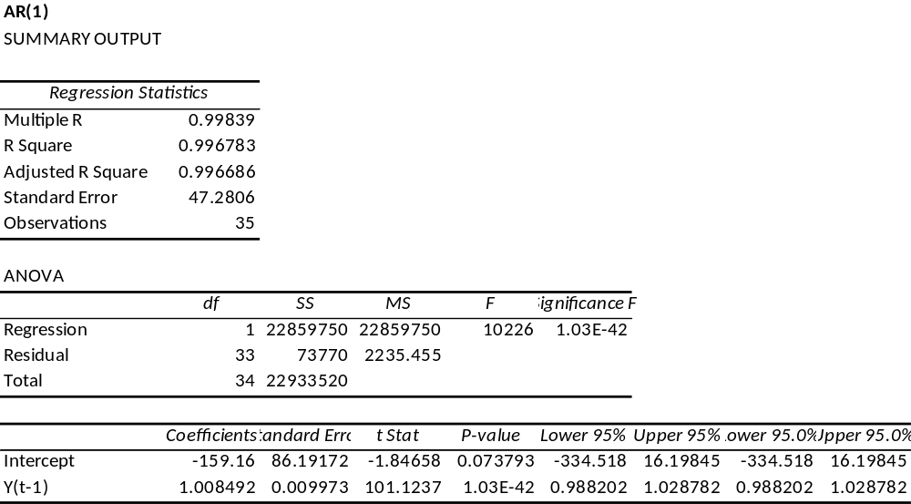

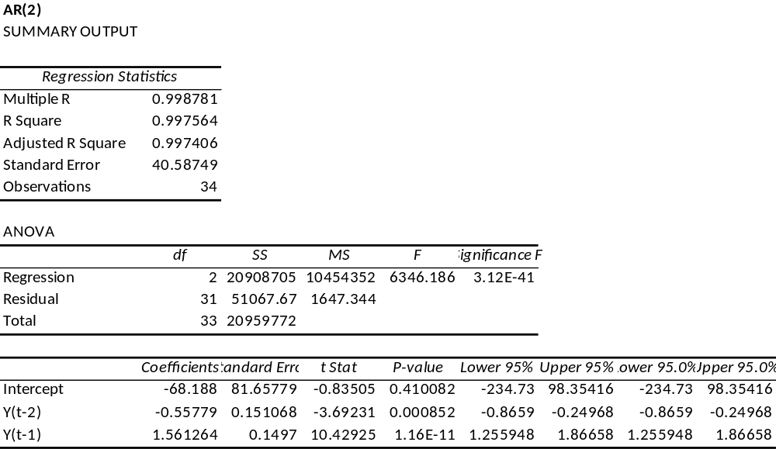

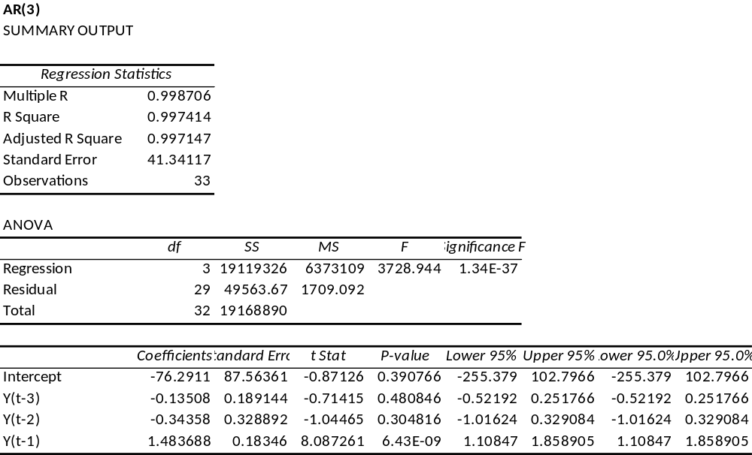

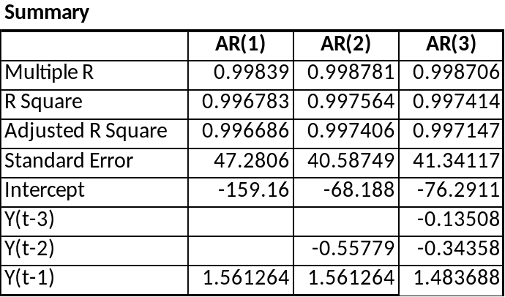

Based on the summary above, it is best to fit the series to AR(2) since though their Multiple R, R Square and Adjusted R Square are almost equal, AR(2) has the least standard error.

Conclusion

The series is best represented by an AR(2) model: Yt = -0.5578Y(t-2) + 1.5613Y(t-1) - 68.1880.
Compared with AR(1) and AR(3), AR(2) has the least standard error of 40.59. This can be verified by the chart below that shows that the expected number of Catholic schools using AR(2) model below is almost equal to actual number of Catholic schools.

